**Part 1: Laravel Installation**

To install Laravel using Composer, I followed these steps:

1. First, I made sure that I have Composer installed on my computer.

2. I opened a command prompt or terminal window and navigated to the directory where I wanted to install Laravel.

3. I opened Laravel official website and follow the documentation for installation the latest version of Laravel.

4. Next, I ran the following command to install the latest version of Laravel:

composer create-project laravel/laravel myproject

5. After the installation process was complete, I navigated into the project directory by running the following command:

cd myproject

5. To verify that Laravel is installed and working correctly, I ran the development server by executing the following command:

php artisan serve

6. Then, I opened my web browser and visited the URL "**http://localhost:8000**". I should have seen the Laravel welcome page. Here's a screenshot of the running server:

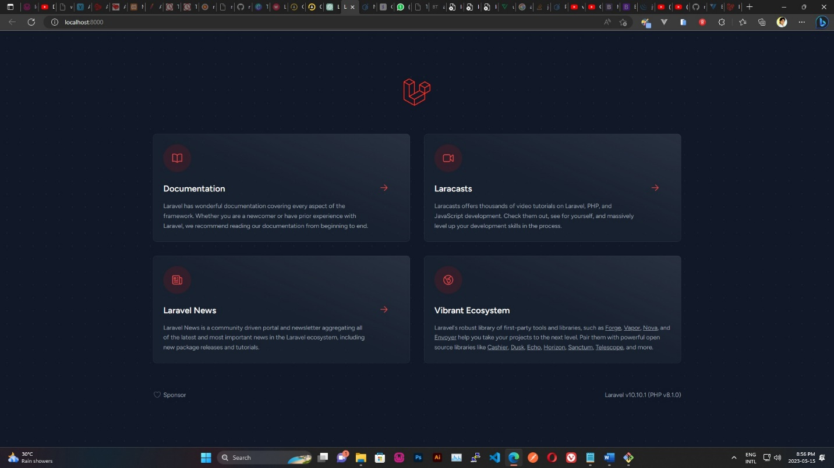

**Part 2: Laravel Folder Structure**

Here's a brief description of each of the following folders in a Laravel project:

* **app:** This folder contains the core application code, including models, controllers, views, and other classes that make up the application's functionality.
* **bootstrap:** This folder contains the files that are responsible for bootstrapping the application, including the autoloaders, the application instance, and the service container.
* **config:** This folder contains all of the application's configuration files, such as the database configuration, mail configuration, and app configuration.
* **database:** This folder contains the application's database-related files, including migrations, seeders, and factories.
* **public:** This folder contains the publicly accessible files for the application, including the index.php file that serves as the entry point for all requests.
* **resources:** This folder contains the application's asset files, such as views, language files, and frontend assets.
* **routes:** This folder contains the application's route files, which define the URLs and corresponding actions for the application's endpoints.
* **storage:** This folder contains the application's temporary files, such as logs, cache files, and session files.
* **tests:** This folder contains the application's automated tests, including unit tests, feature tests, and browser tests.
* **vendor:** This folder contains all of the application's dependencies, which are installed via Composer.

To create a new route that displays a "Hello, World!" message, I opened the routes/web.php file and added the following code:

Route::get('/hello', function () {

return 'Hello, World!';

});

Then, I visited the URL "**http://localhost:8000/hello**" in my web browser. Here's a screenshot of the running route:

